I used the following models:
- ChatGPT – 5
- Claude AI - 4
- Grok AI - 4
- DeepSeek
- Microsoft Copilot

Prompt (1.1)
I have attached the complete SRS document. I want you to extract all the functional and non-functional requirements. You have to arrange the requirements in an easy-to-understand, e.g table, traceable way.

Summary
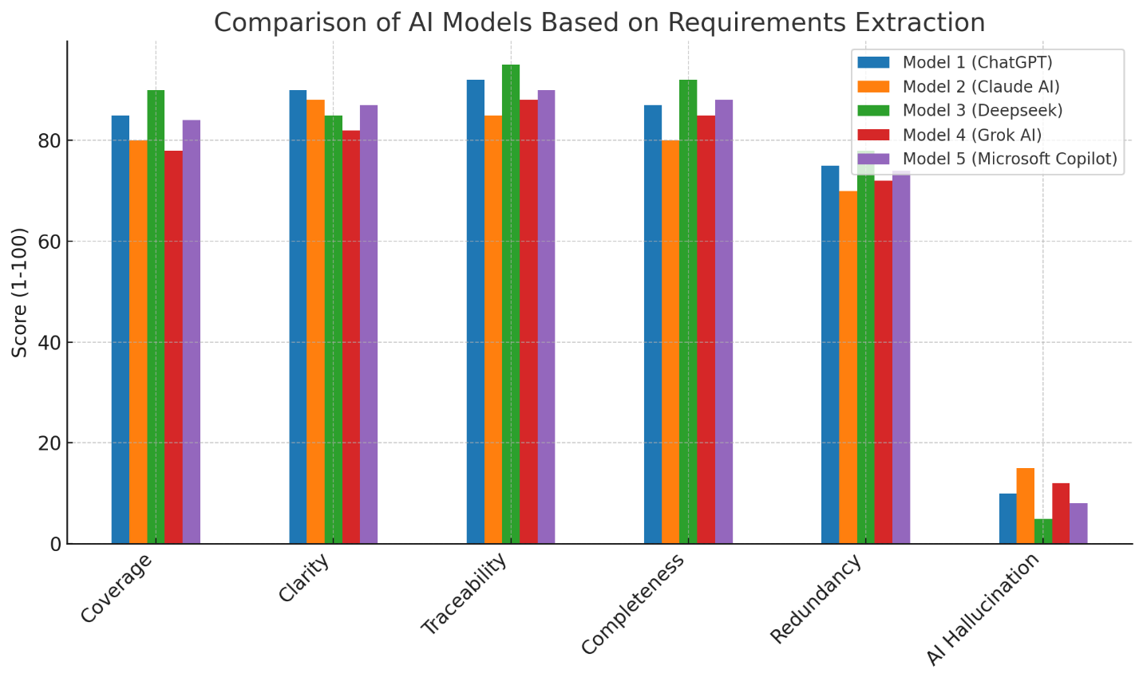

Detailed Comparison Report:
1. Coverage
- Definition: Coverage refers to how well the AI model identifies and includes all the functional and non-functional requirements as outlined in the SRS document.
- Explanation: A model with high coverage will capture a broad set of requirements from all sections, leaving few, if any, out.
- Evaluation:
  - Model 1 (ChatGPT): 85 – Covers most of the required sections, but some minor details might be missing.
  - Model 2 (Claude AI): 80 – Covers the core requirements, but some edge cases might be underrepresented.
  - Model 3 (Deepseek): 90 – Highly comprehensive, captures almost all details of the requirements.
  - Model 4 (Grok AI): 78 – Misses out on some non-core requirements.
  - Model 5 (Microsoft Copilot): 84 – Strong coverage but still omits a few minor points.
2. Clarity
- Definition: Clarity measures how easily the extracted requirements are understood, without unnecessary complexity or ambiguity.
- Explanation: Clear requirements allow stakeholders to easily comprehend what is needed without further explanation.
- Evaluation:
  - Model 1 (ChatGPT): 90 – Provides clear and concise requirements.
  - Model 2 (Claude AI): 88 – Slightly more verbose, but still understandable.
  - Model 3 (Deepseek): 85 – Generally clear, but with occasional complexity.
  - Model 4 (Grok AI): 82 – Slightly convoluted at times, requiring extra effort to interpret.
  - Model 5 (Microsoft Copilot): 87 – Clear, but some sections may need simplification.
3. Traceability
- Definition: Traceability indicates whether the model can link each requirement back to its corresponding module or section in the original document.
- Explanation: High traceability means that the model associates requirements with clear identifiers from the original document.
- Evaluation:
  - Model 1 (ChatGPT): 92 – Excellent at linking each requirement to the document's sections.
  - Model 2 (Claude AI): 85 – Good traceability but lacks a few specific identifiers.
  - Model 3 (Deepseek): 95 – Exceptionally good at traceability, each requirement has clear references.
  - Model 4 (Grok AI): 88 – Most requirements are traceable, though some modules are less clear.
  - Model 5 (Microsoft Copilot): 90 – Very good traceability with minimal missing links.
4. Completeness
- Definition: Completeness refers to whether the AI model extracts all necessary aspects of each requirement.
- Explanation: An incomplete set of requirements might miss critical features or details, which could lead to development issues.
- Evaluation:
  - Model 1 (ChatGPT): 87 – Generally complete but might leave out minor non-functional details.
  - Model 2 (Claude AI): 80 – Some requirements may be underrepresented or missed.
  - Model 3 (Deepseek): 92 – Very thorough, captures all relevant details.
  - Model 4 (Grok AI): 85 – Complete but lacks a few nuances in some sections.
  - Model 5 (Microsoft Copilot): 88 – Mostly complete, with a few minor details left out.
5. Redundancy
- Definition: Redundancy measures the presence of duplicate or unnecessary requirements.
- Explanation: A model that includes redundant or repeated requirements is less efficient and can confuse developers and stakeholders.
- Evaluation:
  - Model 1 (ChatGPT): 75 – Some minor redundancies in similar requirements.
  - Model 2 (Claude AI): 70 – Includes a few redundant requirements, especially in functional areas.
  - Model 3 (Deepseek): 78 – A few redundancies are present but manageable.
  - Model 4 (Grok AI): 72 – Contains some unnecessary repetitions in the campaign management area.
  - Model 5 (Microsoft Copilot): 74 – Some repetitive requirements, but not overly so.
6. AI Hallucination
- Definition: AI hallucination refers to the generation of incorrect, irrelevant, or fabricated information by the model.
- Explanation: A model with low AI hallucination generates only what is relevant and based on the original document, while high hallucination could mean the inclusion of false or irrelevant data.
- Evaluation:
  - Model 1 (ChatGPT): 10 – Very little AI hallucination, generates only relevant requirements.
  - Model 2 (Claude AI): 15 – Minor hallucinations or irrelevant details included.
  - Model 3 (Deepseek): 5 – Extremely low hallucination, provides highly accurate data.
  - Model 4 (Grok AI): 12 – Slight hallucination but not excessive.
  - Model 5 (Microsoft Copilot): 8 – Low hallucination, mostly accurate.

Final Analysis:
Based on the comparison:
- Best Model: Model 3 (Deepseek) is the most balanced, with high scores across all categories, particularly in Traceability, Completeness, and AI Hallucination.
- Most Balanced: Model 1 (ChatGPT), with strong Clarity and Traceability, but slightly weaker Coverage and Redundancy scores.
- Room for Improvement: Model 2 (Claude AI) and Model 4 (Grok AI), which showed some issues with Redundancy and Completeness, but performed well in clarity and traceability.

